**Retail Sales Analysis: Key Insights and Recommendations**

**Introduction**:  
This analysis evaluates retail sales data to identify seasonal trends, regional performance, and product category contributions, with the goal of optimizing sales strategies and improving revenue.

**Key Insights**:

* **Seasonal Trends**:
  + Sales peaked in November with $117938.155 and were lowest in February with $4519.892.
    - Peak month: 2018-11 with sales of $ 117938.155
    - Lowest month: 2015-02 with sales of $ 4519.892

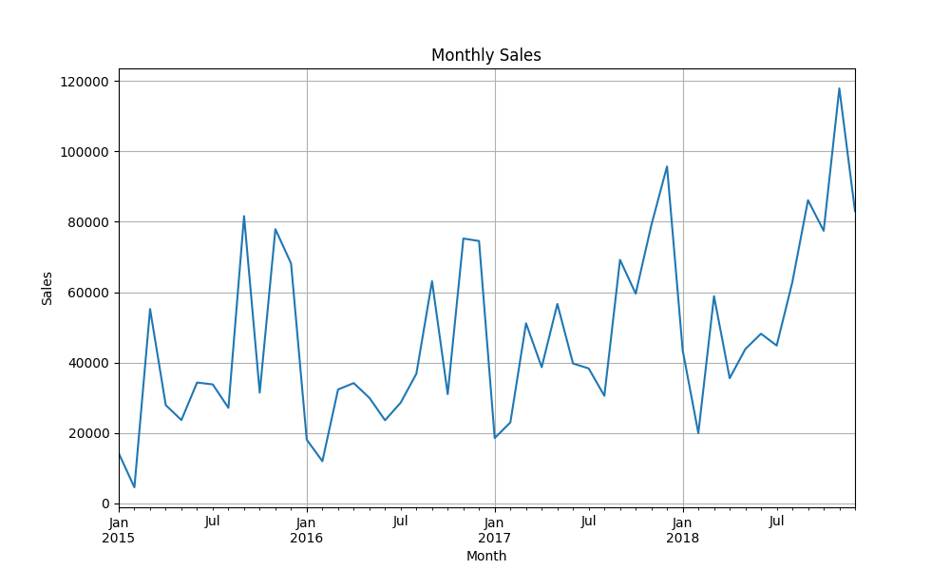

Figure 1: Monthly Sales Trend

* **Regional Performance**:
  + Region West contributed 31.404295076380933 % of total revenue, making it the highest-performing region.

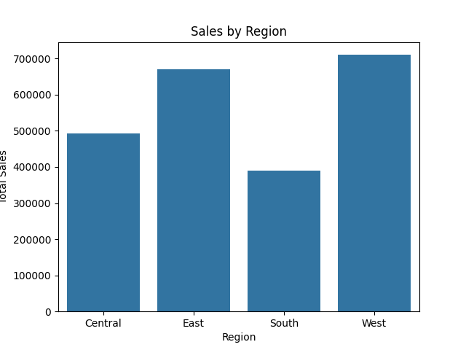

Figure 2: Regional Sales Performance

* **Product Performance**:
  + Technology accounted for $827455.873 in revenue, followed by Furniture with $728658.5757.

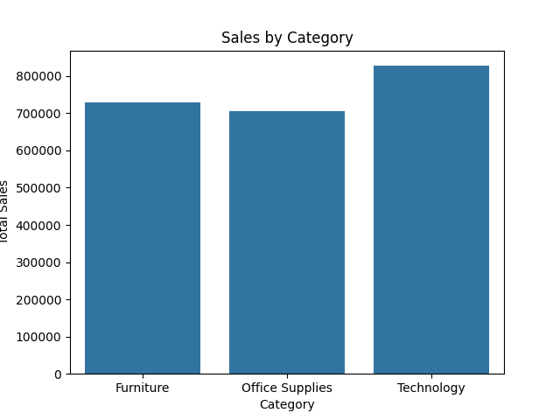

Figure 3: Sales Performance by Category

* The **"**Canon imageCLASS 2200 Advanced Copier**"** generated $61,599.82 as the highest-selling product, followed by the **"**Fellowes PB500 Electric Punch Plastic Comb Binding Machine with Manual Bind,**"** which generated a total of $27,453.38.

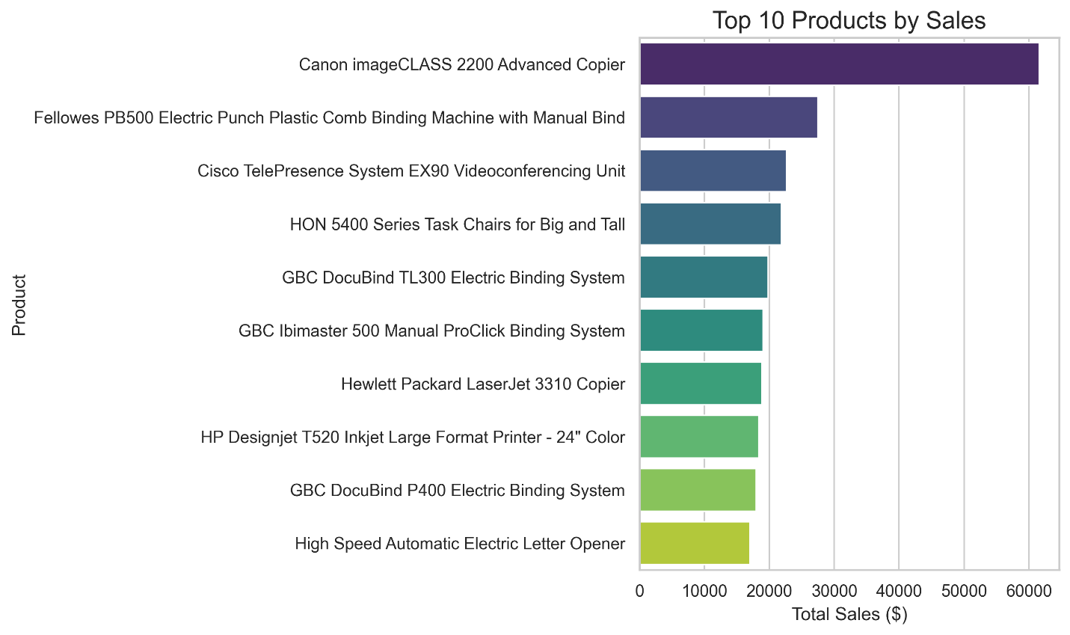

Figure 4: Top Products by Sales

**Recommendations**

**1. Seasonal Sales Trends**

* **Boost November Sales**: Launch pre-holiday promotions in October, focusing on Technology products.
* **Increase February Sales**: Offer discounts and bundle deals on Furniture and Technology.

**2. Regional Performance**

* **Invest in the West**: Increase marketing efforts and customer retention programs in the West region.
* **Replicate Success**: Study the West region’s strategies and apply them to underperforming regions.

**3. Product Performance**

* **Focus on Technology**: Expand offerings and promote high-demand items like printers and copiers.
* **Leverage Top Sellers**: Highlight the "Canon imageCLASS 2200" and "Fellowes PB500" in campaigns.
* **Bundle Deals**: Pair Furniture and Technology products to attract businesses.

**4. General Recommendations**

* **Optimize Inventory**: Stock top-performing products ahead of the November peak.
* **Use Customer Insights**: Collect feedback to refine regional and product strategies.
* **Analyze Trends Regularly**: Monitor sales data to adapt strategies dynamically.

**Conclusion**

By prioritizing the West region and capitalizing on the strong performance of the Technology category, the company can drive sustainable revenue growth. Addressing underperforming months through targeted promotions and aligning marketing efforts with peak sales periods will further enhance profitability. These strategic initiatives are projected to significantly boost overall sales and strengthen the company's market position.